Gelatine hydrogels, 3% w/V, crosslinked with TGM
Compression test for gelatine gels
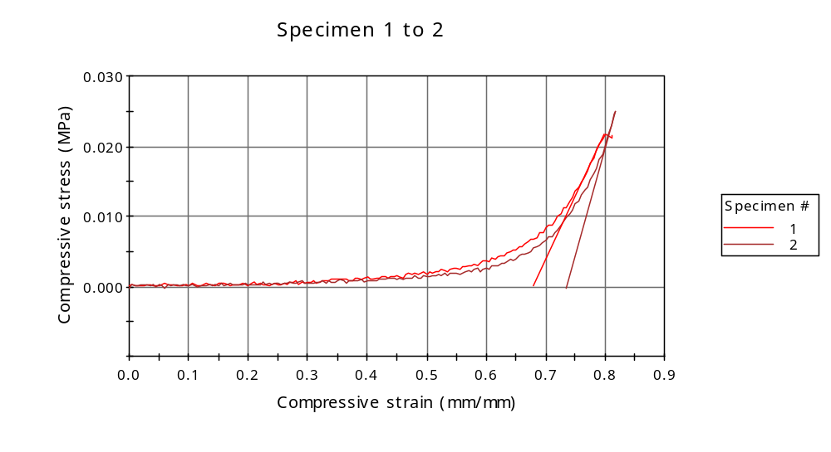
Graph 2
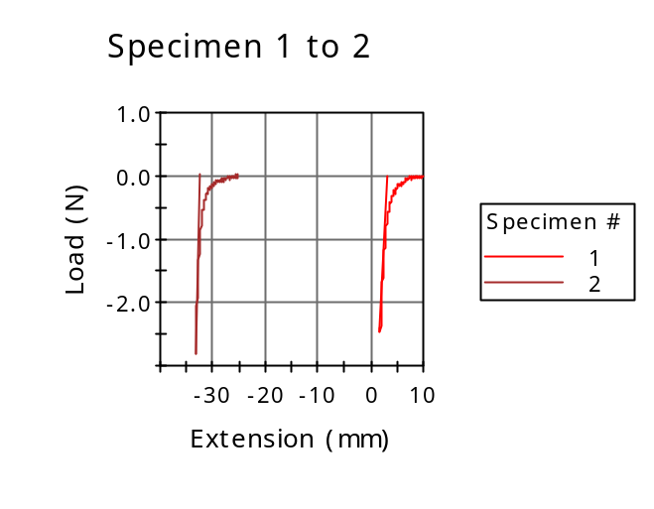

Dimension: Geometry | Circular
Dimension: Diameter | 12.00000 mm
Dimension: Anvil height | 10.00000 mm
Notes: Specimen note 1 | Cylindrical sample compression

 | Diameter  (mm) | Specimen label | Axial Gauge Length (Strain Source)  ()
1 | 12.00000 |  | -10.00000
2 | 12.00000 |  | -10.00000
Mean | 12.00000 |  | -10.00000
Standard Deviation | 0.00000 |  | 0.00000
Coefficient of Variation | 0.00000 |  | 0.00000

 | Anvil height  (mm) | Compressive load at Break (Standard)  (N) | Load at Break (Standard)  (N)
1 | 10.00000 | 2.42633 | -2.42633
2 | 10.00000 | 2.82413 | -2.82413
Mean | 10.00000 | 2.62523 | -2.62523
Standard Deviation | 0.00000 | 0.28129 | 0.28129
Coefficient of Variation | 0.00000 | 10.71479 | -10.71480

 | Load at Yield (Zero Slope)  (N) | Maximum Slope (Automatic Young's)  (MPa/mm/mm) | Modulus (Automatic)  (MPa)
1 | -0.07857 | 0.18192 | 0.13871
2 | ----- | 0.31057 | 0.16230
Mean | -0.07857 | 0.24625 | 0.15050
Standard Deviation | ----- | 0.09097 | 0.01668
Coefficient of Variation | ----- | 36.94238 | 11.08289

 | Compressive load at Yield (Zero Slope)  (N) | Extension at Yield (Zero Slope)  (mm) | Compressive strain at Break (Standard)  (mm/mm)
1 | 0.07857 | 7.72725 | 0.81119
2 | ----- | ----- | 0.81652
Mean | 0.07857 | 7.72725 | 0.81385
Standard Deviation | ----- | ----- | 0.00377
Coefficient of Variation | ----- | ----- | 0.46346

Compressive stress at Break (Standard)
(MPa)
1 | 0.02145
2 | 0.02497
Mean | 0.02321
Standard Deviation | 0.00249
Coefficient of Variation | 10.71480

